Department of Agronomy
College of Agriculture
CAU: Imphal

To Date: 23/12/2019
The Dean
College of Agriculture
Central Agricultural University
Imphal.

Sub.: Submission of Final report of DST Project along with Utilization Certificate & CDs.

Sir,

I am to submit herewith, the Final report along with Utilization Certificate in respect of the short term project sanctioned by Department of Science & Technology Government of Manipur entitled “Study on yield and economics of rapeseed-mustard influenced by different tillage systems under rice fallow condition” implemented during Rabi season of 2018-19. The Utilization Certificate of funds under the project along with the whole documents in 3 Nos. of CD is also attached for necessary perusal and signature please.
Further, the report is to be submitted urgently to the Funding Agency and Directorate of Research, CAU, Imphal at the earliest.

Yours faithfully,
Encl. As stated
(Dr. J. Lhungdim)
Asst. Professor & P.I.

FINAL REPORT

ON

“Study on yield and economics of rice-rapeseed-mustard
Influenced by different tillage systems under rice fallow condition”

A DST-Manipur Short-term R&D project (2017-18)

Financed/supported by:
Department of Science & Technology
Government of Manipur, Imphal

Submitted by:
Dr. Jamkhogin Lhungdim
Asst. Professor (Sr.Scale)



DEPARTMENT OF AGRONOMY
COLLEGE OF AGRICULTURE
CENTRAL AGRICULTURAL UNIVERSITY
IMPHAL, MANIPUR-795004
FINAL REPORT
ON
A DST-Manipur Short-term R&D project
CENTRAL AGRICULTURAL UNIVERSITY, IMPHAL (MANIPUR)
- Title of the research project : Study on yield and economics of rapeseed-mustard as
influenced by different tillage systems under rice fallow condition.
- Name of the Project Investigator : Dr. Jamkhogin Lhungdim
- Designation : Asst. Professor (Sr. Scale)
- Organization : Department of Agronomy, College of Agriculture,
CAU, Impha,l Manipur
- Name of the Co- PI : Dr. K. Nandini Devi
- Designation : Professor
- Organization : Department of Agronomy
College of Agriculture, CAU, Imphal, Manipur
- Location of the experimental site : Sanjenbam, P.S. Lamshang, Imphal West, Manipur
- Season and Year of experimentation: Rabi, 2019
- Project cost : Rs. 95,000/-
- Project sanction order no. & date : 10/4/2011-R&D/DST/542 dated, 25th January, 2018.
(Date of release of fund: 31/3/2019)

- Project code : DST-Manipur Short-term R&D project, 2017-18
- Project duration : One year
- Date of start of the project :1st December, 2018

- Objective:
- To compare the yield performance of rapeseed-mustard varieties (local yella vs M-27)
- Comparative study on economics of cultivation amongst rapeseed-mustard varieties.
- Economics on different tillage system for yield advantage of rapeseed-mustard.
- Research/Technical achievements:
Technical and physical achievements were made, data collected from the research for the College/University were of great value. The result/finding is being applied to the farmer’s field for effective adoption.

- INTRODUCTION
In Manipur, the mostly consumed oil is from Rapeseed-mustard which is the predominant crop grown during rabi season after paddy under rainfed conditions. The variety M-27 and Local variety- Yella are the two popular rapeseed and mustard varieties grown in the state. Different sowing techniques have been practiced in zero tillage cultivation of rapeseed and mustard in Manipur viz. relay crop (Uttera cropping), sowing seeds after burning straw/residues and sowing seeds with straw mulching. In relay crop, if the soil moisture is optimum as indicated by soil coloration and field test, the seeds are sown in standing paddy field just 4-7 days before harvesting of paddy. After harvesting of paddy, as the seed germinates with 1-2 true leaves, urea is top dressed at the rate of 120-150 kg/ha. The crop is then allowed to complete its life cycle without much of after care, but insecticides are applied on need based approach. Under the second method (burning straw/residues), the farmers harvest paddy crop at the height of 15-20 cm. The threshed out paddy straws are thinly scattered over the entire rice field and then burnt. Mustard seeds are sown in the following days. The method is more advantageous in moist field and also helps in controlling weeds during burning. Under the third method, it is practiced with the presumption that the soil moisture is drying fast and mustard seeds may not be able to germinate. So the straws are scattered thinly over the field after sowing of mustards seeds to serve as mulch for conserving soil moisture.
Tillage operations are varied in practice. Soil preparation and making a sufficient seed bed is so important in rapeseed cultivation because of small and sensitive seeds. Suitable seed bed is one of the efficient factors on exceeding yield and decreasing production coasts. Zero tillage is one of the most used RCTs (Gupta, 2007) employed for saving precious resources, which gives more economic production (Hobbs, et al., 2002), lower production cost and saving water and energy (Reifschneider, 2007). Zero tillage not only promotes input-use efficiency but also strengthens natural resource base (Laxmi and Mishra, 2007). It is, in a way, a complete farm management system that should include many agricultural practices including planting, plant residue management, weed and pest control, harvesting and crop rotations (Ekboir, 2002). Conservation agriculture is also a major focus in the Indian agriculture in order to sustain the quality of natural resources and to meet the challenges of ever increasing demands for food, fodder and fuel of the country where it is a concept for resource saving agricultural crop production that strives to achieve acceptable profits together with high and sustained production levels while concurrently promoting the environmental balance. Moreover, along with conservation agriculture, crop diversification proved to be of paramount importance in mitigating the environmental problems arising on account of monoculture.
A mustard seedbed is firm, moist, and uniform which allows good seed-to-soil contact, even planting depth and quick moisture absorption leading to a uniform germination. Tillage affects both
crop growth and grain yield. The various tillage systems are conventional tillage which involves moldboard ploughing followed by disc harrowing; reduced tillage that includes disc ploughing followed by disc harrowing and complete zero tillage in which crop is sown under uncultivated soil. Minimum tillage, with or without straw, enhances soil moisture conservation and moisture availability during crop growth. As a consequence, the root mass, yield components and seed yield are increased (Chauhan et al., 2006). Zero tillage is preferred in mustard as it conserves more moisture in the soil profile during early growth period. Subsequent release of conserved soil moisture regulates proper plant water status, soil temperature, lower soil mechanical resistance, leading to better root growth and higher grain yield of mustard (Rathore et al., 1999). Success with minimum or zero tillage requires even distribution of crop residues, as a well-designed crop rotation and evenly distributing residue will create a firm, moist and uniform seedbed. Various sowing techniques have been practiced in zero tillage cultivation of rapeseed and mustard in Manipur viz. as relay crop, sowing seeds after burning straw; and sowing seeds with straw mulching (Monika et al., 2014). Conventional tillage however is done with repeated ploughing, discing and rotavating till a fine tilth is obtained. This incurred higher cost of land preparation at the same time higher yield. This method is uncommon among farmers of Manipur as the benefit: cost ratio is normally low.
- MATERIAL AND METHODS
The research was conducted at Sanjenbam, P.S. Lamshang, Imphal West, Manipur during rabi season of 2018. The research was conducted on one ha area under lowland condition. All inputs/research materials and labour charges were provided from the project fund while land was donated by the participating farmer without rent/charges. The produce was given to the farmers as a compensation to the land use free of cost. Two rapeseed-mustard varieties (M-27 and local yella) were the crop factor while three types of tillage system (zero tillage, minimum tillage, conventional tillage and Uttera cropping) were another factor comprising eight (8) treatment combinations. Soil samples were collected for initial and final nutrient status. Tillage operation was done in early December, 2018 once by using disc plow followed by once with moldboard plow and once by rotavator for Conventional tillage (CT), once disk plow followed by one moldboard for Minimum tillage (MT), without any tillage operation for Zero tillage (ZT) treatments and sowing of seeds in standing rice crop for Uttera cropping(UC) 15 days before rice harvest. Twice disk plow for CT and once disk plow for MT treatments were fulfilled in late November and before planting. Comparison between profitability of the two rapeseed-mustard varieties with full packages were evaluated in respect of yield performance and other yield contributing parameters. Normal plant nutrient sources (fertilizers) as in the case of scientific cultivation of the crop (NPK @ 60:40:30 kg/ha) were commonly applied in both the conditions basally. FYM @ 15t/ha was applied in all the land treatments in three replications.
Rapeseed-mustard was sown after harvest of rice and before harvest in case of Uttera cropping to determine the profitability of the cultivation under the various tillage systems. The pants were harvested after the physiological ripening in each plot with eliminating. To determine the yield parameters, 10 samples of each plot were randomly selected and number of siliquae per plant, number of seeds per siliqua, and thousand-grain weight were measured. The factors for treatment combination were as follows:
Treatments
Factor1: Rapeseed-mustard varieties
i) M-27 ii) Local yella
Factor2: Tillage system
i) Zero tillage ii) Minimum tillage
iii) Conventional tillage iv) Uttera cropping
Data collected from the research project were subjected to statistical analysis with Randomized Block design (RBD) using OPSTAT statistical software.
Treatment combinations:
T₁: M-27 x Zero tillage
T₂: M-27 x Minimum tillage
T₃: M-27 x Conventional tillage
T₄: M-27 x Uttera cropping
T₅: Local yella x Zero tillage
T₆: Local yella x Minimum tillage
T₇: Local yella x Conventional tillage
T₈: Local yella x Uttera cropping
The following formulae were used for different parameters as below:
Harvest index = $\frac{Economic yield/grain yield}{Biological yield } x 100$
Economics of cultivation was worked out based on the expenditures and incomes at prevailing local prices of inputs, labour charges and selling price of the grains and straws. Various economic calculation parameters were determined with formulae below:
Net return = Gross return - Total cost of cultivation
Benefit-cost ratio = $\frac{Net return}{Total cost of cultivation}$
Meteorological data during the cropping season June-November, 2017
Weather data during the Experimental season (2018-19) was collected from the Gramin Krishi Mausam Seva, ICAR Research Complex for NEH Region, Manipur Centre, Lamphelpat, Imphal which falls under the same agro-climatic zone of the experimental site as shown as below:

Meteorological data (Mean) during the cropping season, 2018-19
Months | Temperature (ºC) |  | Relative humidity (%) |  | Total Rainfall  (mm) | Sunshine  (hr)
Months | Max. | Min. | Max. | Min. | Total Rainfall  (mm) | Sunshine  (hr)
Nov, 2018 | 25.7 | 9.4 | 86.4 | 47.1 | 0.4 | 8.6
Dec., 2018 | 22.9 | 7.4 | 89.5 | 47.8 | 0.8 | 7.2
Jan., 2019 | 23.7 | 4.6 | 91.8 | 36.6 | 0.1 | 8.7
Feb., 2019 | 24.7 | 7.7 | 87.6 | 41.2 | 0.7 | 6.9
Mar., 2019 | 26.6 | 11.2 | 83.6 | 40.9 | 1.2 | 7.1
Apr., 2019 | 29.4 | 15.3 | 84.4 | 47.6 | 2.6 | 7.0
Source: Experimental Agromet Advisory Service, ICAR Research Complex for NEH Region,
Manipur Centre, Lamphelpat, Imphal (Manipur).

- RESULTS AND DISCUSSION

- Growth parameters and yield attributes
Plant height
Maximum plant height was recorded in the treatment Local yella x Conventional tillage (170 cm) whereas, the least plant height was observed with M-27 x Uttera cropping that was statistically at par with M-27 x Zero tillage. Plant height was on average more with Conventional tillage followed by Minimum tillage and comparatively lower with Zero tillage and Uttera cropping. Local yella was observed with taller plants compared to M-27 variety.
Branches/plant
Branching potential of both the varieties were similar. However, highest branching potential was observed in the treatment M-27 x Conventional tillage (9.50) that was statistically comparable with Local yella x Conventional tillage. Minimum branches were recorded in M-27 x Zero tillage. On average, more profuse branching was recorded with Conventional tillage followed by Minimum tillage and comparatively lower with Zero tillage and Uttera cropping. M-27 was observed with more branching habit compared to local yella.
Siliqua/plant
Significantly highest siliquae/plant was recorded in the treatment M-27 x Conventional tillage (221) followed by Local yella x Conventional tillage whereas, the least Siliquae/plant was observed with Local yella x Uttera cropping that was statistically at par with M-27 x Zero tillage. Siliquae/plant was on average more with Conventional tillage followed by Minimum tillage and comparatively lower with Zero tillage and Uttera cropping. The silique number was observed with M-27 but statistically at par with local yella. This result was in conformity with Ranjbar et al. (2014).
Seeds/siliqua
Data on seeds/silique showed that there were no remarkable differences. However, highest seeds/siliqua was observed in the treatment M-27 x Conventional tillage (12.50) that was statistically comparable with Local yella x Conventional tillage (11.00). Minimum seeds/silique were recorded in M-27 x Zero tillage (8.00) that was statistically at par with Local yella x Uttera cropping (8.50). On average, more seed bearing was recorded with Conventional tillage followed by minimum tillage and comparatively lower with Zero tillage and Uttera cropping in both the crop varieties.
Test weight
In respect of test weight, there was no significant differences between varieties (M-27 and local yella) and between all the tillage methods except Zero tillage and Uttera cropping. However, interaction between varieties and tillage method showed that, maximum test weight was recorded in Local yella with Conventional tillage (4.50 g) followed by M-27 with Conventional tillage (4.30 g). Minimum test weight was observed in M-27 with Uttera Cropping (3.90 g) and M-27 with Zero tillage (4.00 g). Ranjbar et al. (2014) also reported similar findings in rapeseed-mustard.
- Biological yield and HI
Highest yield was recorded in M-27 under conventional tillage system (9.00 q/ha) that was statistically at par with Local yella with Conventional tillage (8.55 q/ha). Statistically, the two
treatments were superior to rest of the treatment combinations under comparison. Minimum yield was observed in Zero tillage and Uttera cropping in both the varieties under trial. In respect of Stover yield M-27 with Conventional tillage (15.55 q/ha) was found to be highest but comparable with Local yella with Conventional tillage (13.50 q/ha) and M-27 with Uttera cropping (13.00 q/ha). Harvest index was highest with M-27 under Zero tillage system (). There were no significant differences between most of the treatments except M-27 with Uttera cropping. This result is in agreement with the work of Shekhawat et al. (2016).
- Economics
The highest net income was generated in the conventional tillage system (₹39,000/ha), which is attributed to the yield response to the tilled seedbed followed by Local yella with Conventional tillage (₹35.85,000/ha). However, the benefit:cost ratio showed highest values of BCR (2.79) in M-27 under Zero tillage system followed by Local yella (2.70) with the same tillage method (ZT). This could be due to least labour and tillage cost involved with the systems. The trend of decreasing BCR in tillage methods viz, conventional tillage and minimum tillage could be attribute due to high cost of labour and fuel in land preparation. The results were supported by the work of Monika et al., (2014) on the same crop in Manipur.

CONCLUSION
From the results of data interpretation, an inference can be drawn with observation that, the most profitable cultivation was under Zero tillage system using the variety, M-27. Farmers can be encouraged with cultivation of this variety (M-27) avoiding high labour cost and least employment of machineries with high fuel use. This may not only reduce cultivation cost, but reduce environmental pollution and high soil compaction for the next crop, rice. The resource poor farmers of the state of Manipur can rely on such minimum input use and over exploitation of labour force. Besides, mustard cultivation under Zero tillage improved productivity, farm economics, sustainability and augmented soil organic carbon and carbon sequestration potential.
Table 1: Effect of tillage method and varieties of Rapeseed-mustard on growth and
yield attributes

Treatment | Pl. ht.  (cm) | Branches/  plant | Siliquae/  plant | Seeds/  siliqua | Test wt. (g)
T₁: M27 x ZT | 135 | 4.00 | 95 | 8.0 | 4.00
T₂: M27 x MT | 150 | 7.00 | 120 | 10.2 | 4.10
T₃: M27 x CT | 165 | 9.50 | 221 | 12.5 | 4.30
T₄: M27 x UC | 130 | 5.50 | 105 | 8.8 | 3.90
T₅: Local yella x ZT | 140 | 3.50 | 110 | 8.4 | 3.80
T₆: Local yella x MT | 155 | 6.50 | 125 | 9.5 | 4.20
T₇: Local yella x CT | 170 | 9.00 | 202 | 11.0 | 4.50
T₈: Local yella x UC | 136 | 5.20 | 80 | 8.5 | 4.10
SEm (±) | 1.645 | 0.634 | 1.560 | 0.550 | 0.320
CD at 5% | 4.95 | 1.90 | 4.56 | 1.62 | NS
CV (%) | 15.55 | 16.5 | 18.32 | 8.85 | 6.82

HI =Harvest index; TCC=Total cost of cultivation; GR=Gross return; NR= Net return; BCR=Benefit-cost ratio

Table 2: Effect of tillage method and different varieties of Rapeseed-mustard on seed yield, HI
and economics

Treatment | Seed yield (q/ha) | Stover yield (q/ha) | HI  (%) | TCC (₹x¹⁰⁰⁰) | GR  (₹x¹⁰⁰⁰) | NR  (₹x¹⁰⁰⁰) | BCR
T₁: M27 x ZT | 6.50 | 10.00 | 39.39 | 12.00 | 45.50 | 33.50 | 2.79
T₂: M27 x MT | 7.50 | 12.00 | 38.46 | 15.50 | 52.50 | 37.00 | 2.39
T₃: M27 x CT | 9.00 | 15.55 | 36.66 | 24.00 | 63.00 | 39.00 | 1.63
T₄: M27 x UC | 6.00 | 13.00 | 31.58 | 14.00 | 42.00 | 28.00 | 2.00
T₅: Local yella x ZT | 6.45 | 10.00 | 39.21 | 12.00 | 45.15 | 33.15 | 2.76
T₆: Local yella x MT | 7.00 | 12.00 | 36.84 | 15.50 | 49.00 | 33.50 | 2.16
T₇: Local yella x CT | 8.55 | 13.50 | 38.78 | 24.00 | 59.85 | 35.85 | 1.49
T₈: Local yella x UC | 6.80 | 9.00 | 39.19 | 14.00 | 40.60 | 26.60 | 1.90
SEm (±) | 1.45 | 1.50 | 5.50 | - | - | - | -
CD at 5% | 4.22 | 5.45 | 12.55 | - | - | - | -
CV (%) | 12.50 | 10.60 | 15.50 | - | - | - | -

HI =Harvest index; TCC=Total cost of cultivation; GR=Gross return; NR= Net return; BCR=Benefit-cost ratio

ACKNOWLEDGEMENT

The Project Investigator is thankful to the Directorate of Science and Technology, Govt. of Manipur, Imphal for financial support and Directorate of Research and College of Agriculture for technical support to carry out this field experiment.

REFERENCES
Chauhan, J. S., Singh, K. H. and Kumar, A. (2006). Compendium of Rapeseed-mustard varieties notified in India,” Directorate of Rapeseed-Mustard Research, Bharatpur, Rajasthan, pp. 7–13,

Ekboir, J. (2002). Developing no-till packages for small-scale farmers. In: Ekboir J. (ed) CIMMYT
2000-2001, World wheat overview ad outlook. CIMMYT, pp.1-38, DF, Mexico.
Gupta, K.R. (2007). RCT induced impacts in Indo-Gangetic Plains. RWC research highlights, 2006.
Rice Wheat Consortium for Indo-Gangetic Plains. New Delhi, India.
Hobbs, P.R., Gupta, R.K., Ladha, J.K., and Balasubramanian, V. (2002). Crop establishment and
management new opportunities for enhancing rice-wheat system productivity. In: Rice-Wheat consortium for the Indo Gangetic Plains, pp 10-30, Rice-Wheat consortium paper series 14, New Delhi.
Laxmi, V. and Mishra, V. (2007). Factors affecting the adoption of resource conserving technology,
case study of zero tillage in rice-wheat farming system. Indian Journal of Agricultural Economics, 62(1): 126-38.
Monika, A., Singh, R, Feroze, S.M. and Singh, R. J. (2014). Zero Tillage of Rapeseed and Mustard
Cultivation in Thoubal District of Manipur: An Economic Analysis. Economic Affairs, 59(3) : 335-343
Ranjbar, H., Mansouri, M., Salar, M. R. and Ala, A. (2014). Effects of different tillage system,
seeding method and rates on yield and seed oil percentage of rapeseed. International journal of Advanced Biological and Biomedical Research, 2 (1):192-201
Rathore, A.L., Pal, A. R. and Sahu, K. K. “Tillage and mulching effects on water use, roogrowth and
yield of rainfed mustard and chickpea grown after lowland rice,” Journal of Science of Food and Agriculture, vol. 78, no. 2, pp. 149–161, 1999.
Reifschneider, F. (2007). Doubley green revolution: Our planet, the magazine of the United Nations
environment programme, agriculture and economic development (special edition). UNEP, Nairobi, Kenya.
Shekhawat, K., Rathore, S.S., Kandpal, B.K., Premi, O.P., Singh, D., Singh, Chauhan, S.B. (2016).
Crop establishment techniques affect productivity, sustainability, and soil health under mustard-based cropping systems of Indian semi-arid regions. Soil and Tillage Research, 158: 137-146.
--------------------------------------------------------------------------------------------------------------

UTILIZATION CERTIFICATE
FOR
A DST-MANIPUR SHORT-TERM R&D PROJECT, GOVT. OF MANIPUR
COLLEGE OF AGRICULTURE
CENTRAL AGRICULTURAL UNIVERSTY
IMPHAL, MANIPUR

1. | Title of Project |  | Study on yield and economics of rapeseed-mustard as  influenced by different tillage systems under rice fallow condition
2. | Name of P1 with designation |  | Dr. Jamkhogin Lhungdim, Asst. Professor (Sr. Scale)  (Dept. of Agronomy, CoA, CAU, Imphal)
3. | Sanction order No.& date |  | 10/4/2011-R&D/DST/542 dated, 25th January, 2018.
4. | Sanction amount |  | ₹ 95,000/- (Released on 31/3/2018)
5. | Project code & Project Period |  | DST-Manipur Short-term R&D project, 2017-18: One year
6. | Location of the project |  | Sanjenbam, P.S. Lamshang, Imphal West, Manipur
7. | Date of Commencement |  | 1st December, 2019
8. | Period of extension ,if any |  | One year
9. | Date of Completion |  | 1st December, 2018
10. | Total project period |  | One year
11. | Date of submission of final report |  | 18/12/2019
12. | Expenditure statement
13. | Operational Expenses | Sanctioned Amount  (₹) | Utilized Amount  (₹) | Left over Amount  (₹)
a. | Materials | 3000 | 2100 | 900
b. | Manpower | 55,000 | 48,988 | 6012
d. | Consumables | 22,000 | 21,950 | 50
e. | Contingency | 15,000 | 12,488 | 2512
 | Total | 95,000 | 85,526 | 9474
14. | Date of last utilization of fund | 20.4.2019
15. | Left over amount | 9474
16 | Financial year | 2019-2020

(Dr. J Lhungdim) Accountant Dean
Asst.Prof. & PI COA,CAU, Imphal COA,CAU, Imphal
COA,CAU, Imphal

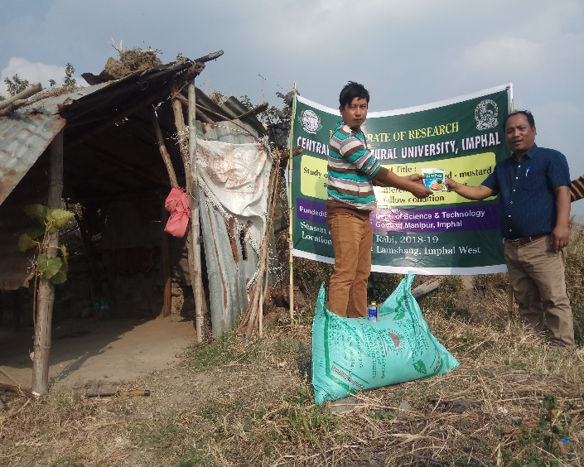
FIELD PHOTOS
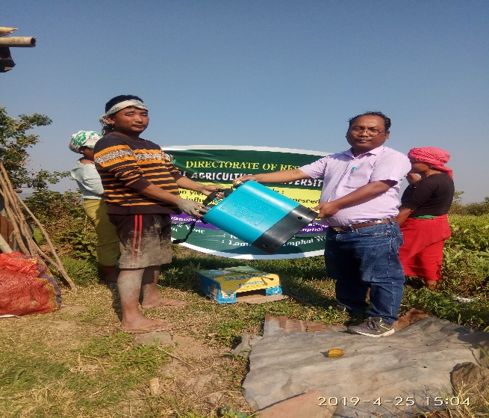
INPUT/EQUIPMENT DISTRIBUTION TO THE BENEFICIARY FARMER
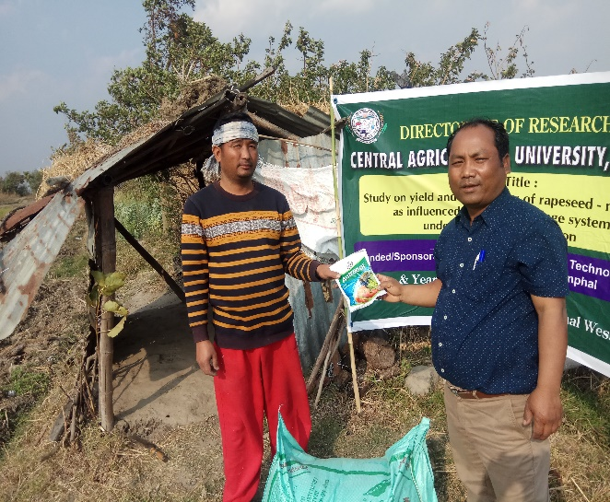
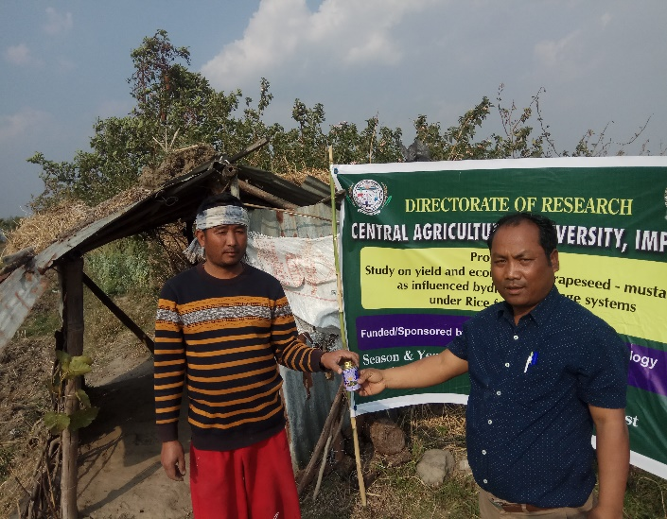
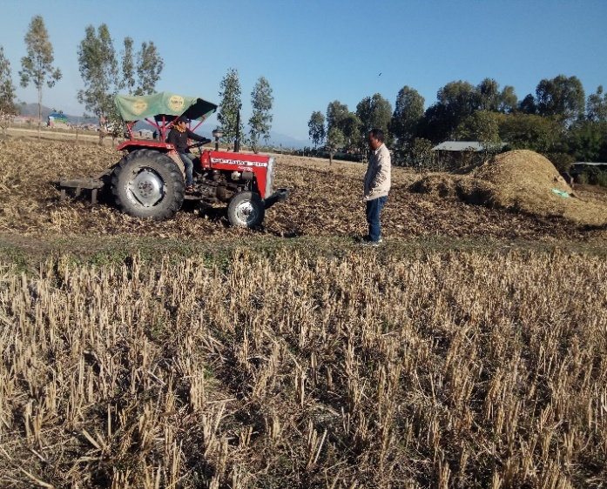
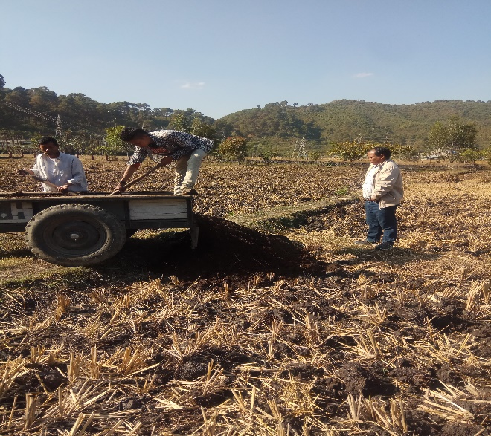
INPUT DISTRIBUTION TO THE BENEFICIARY FARMER
FYM APPLICATION AND PLOUGHING/INCORPORATION

CROP AT FLOWERING STAGE
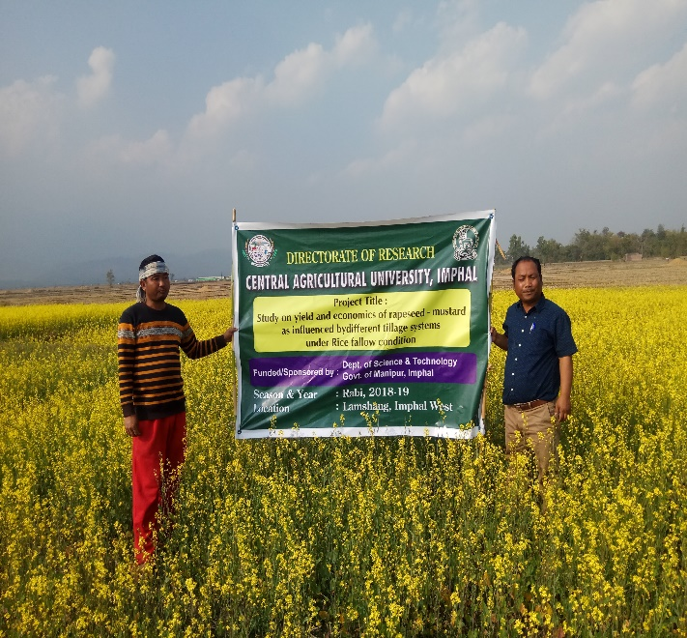
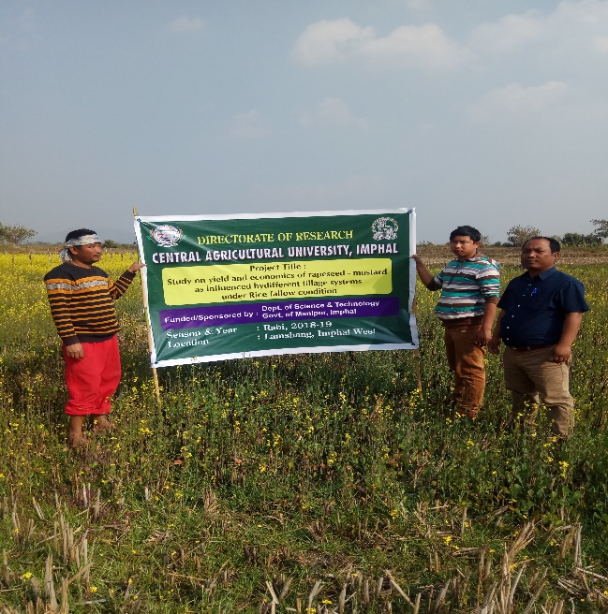
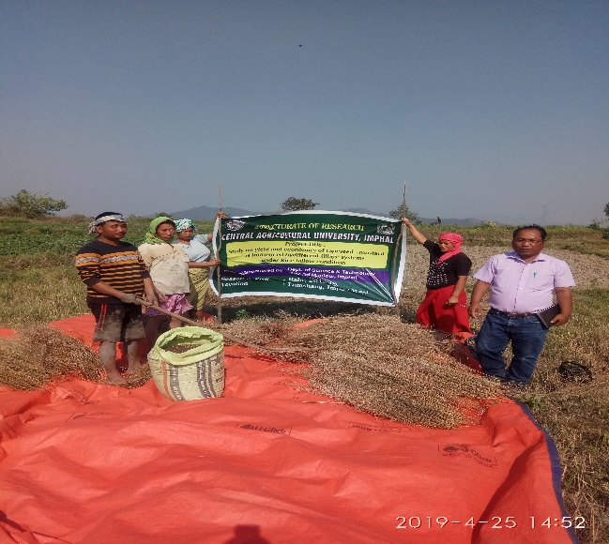
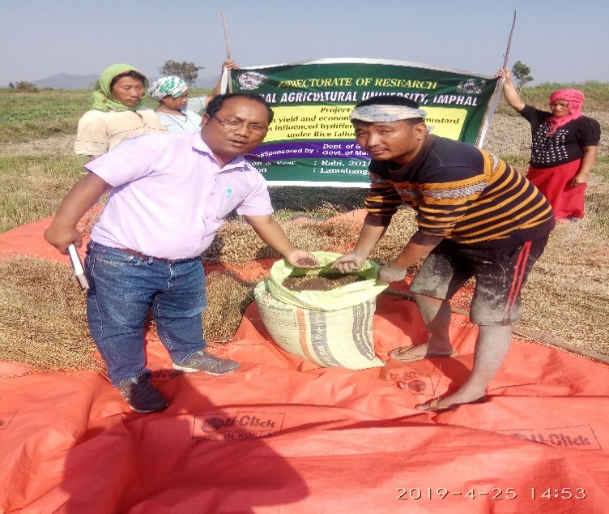
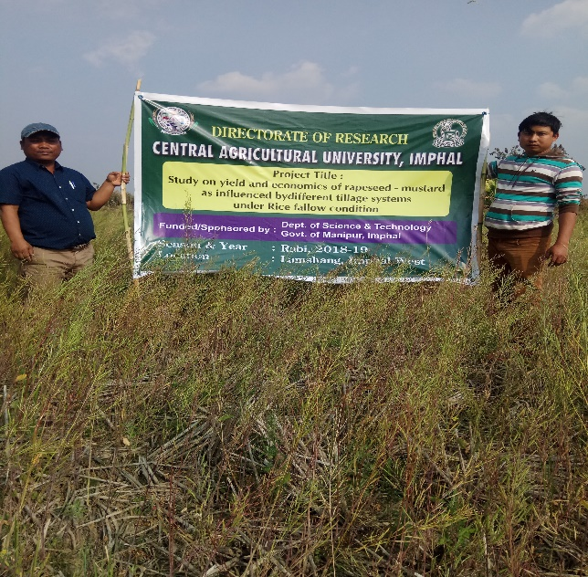
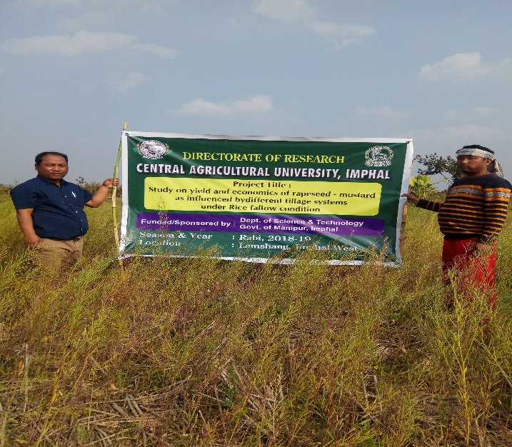
CROP AT MATURITY STAG
CROP HARVESTED

